1. FIBONACCI SERIES

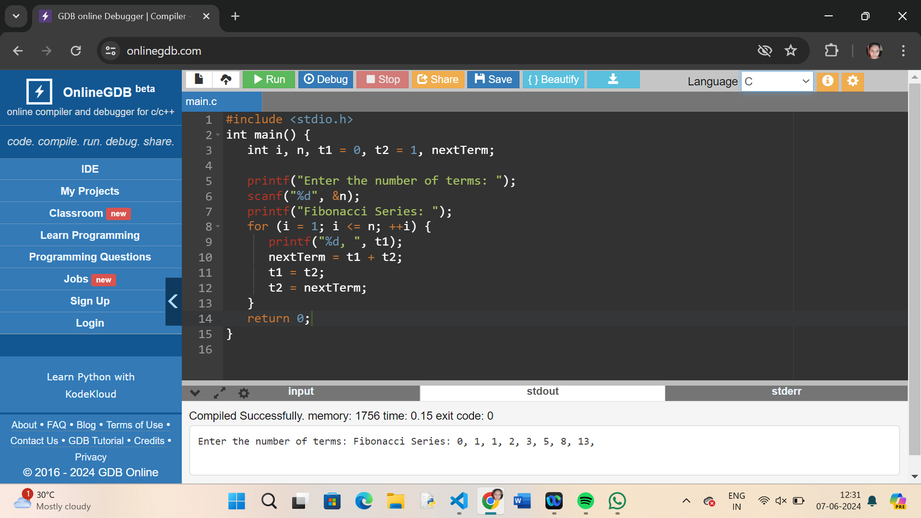

1. ARMSTRONG NUMBER

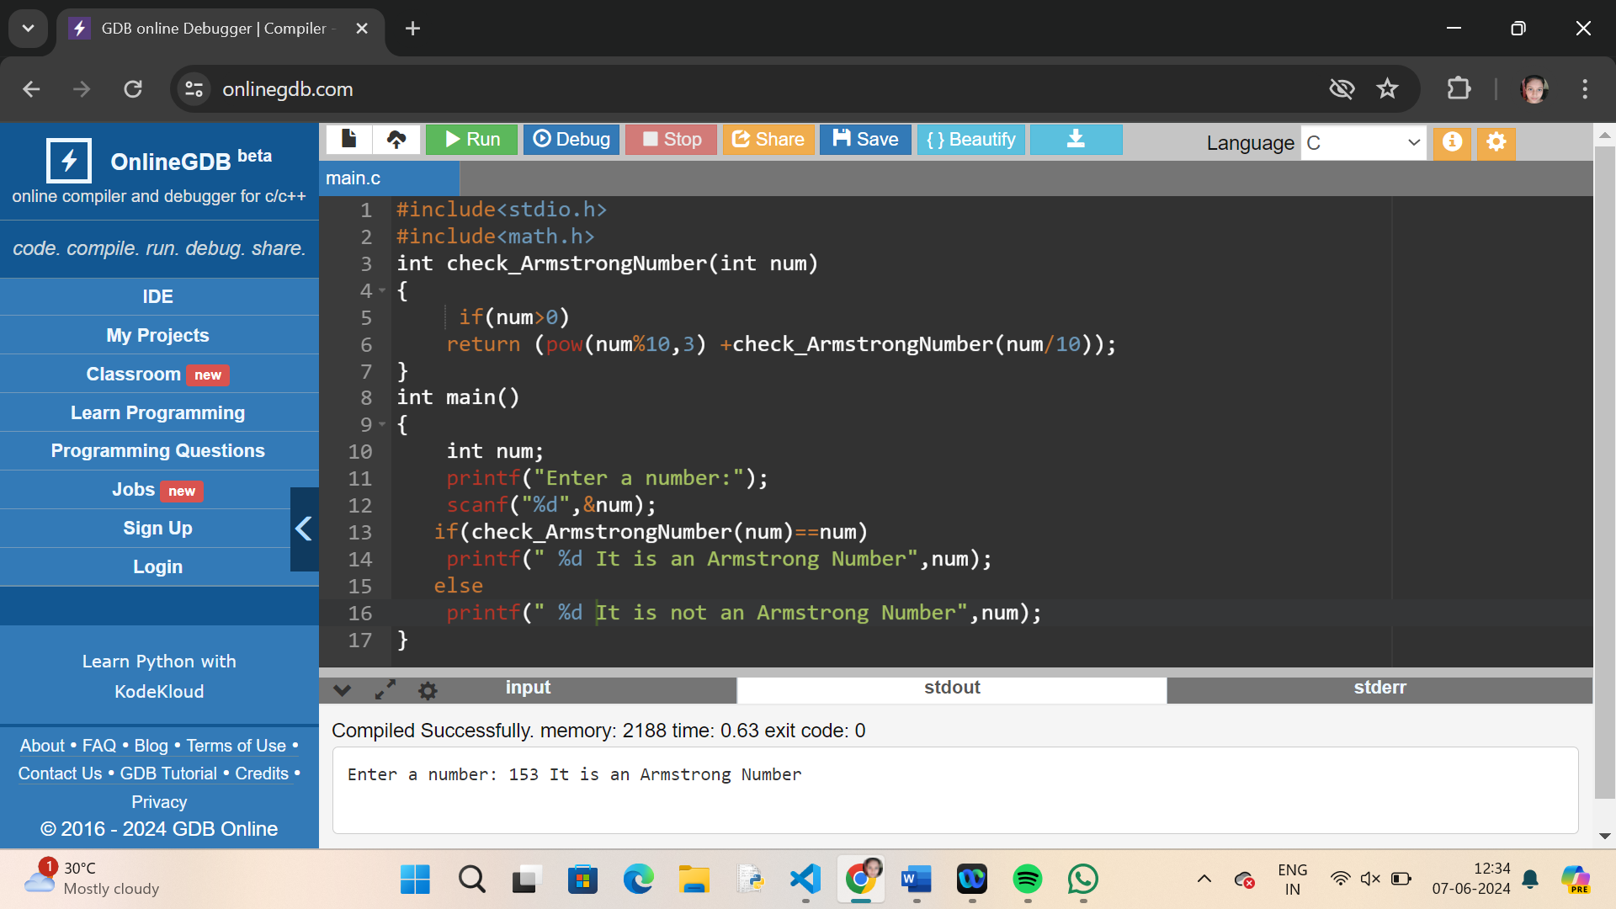

1. GCD OF TWO NUMBERS

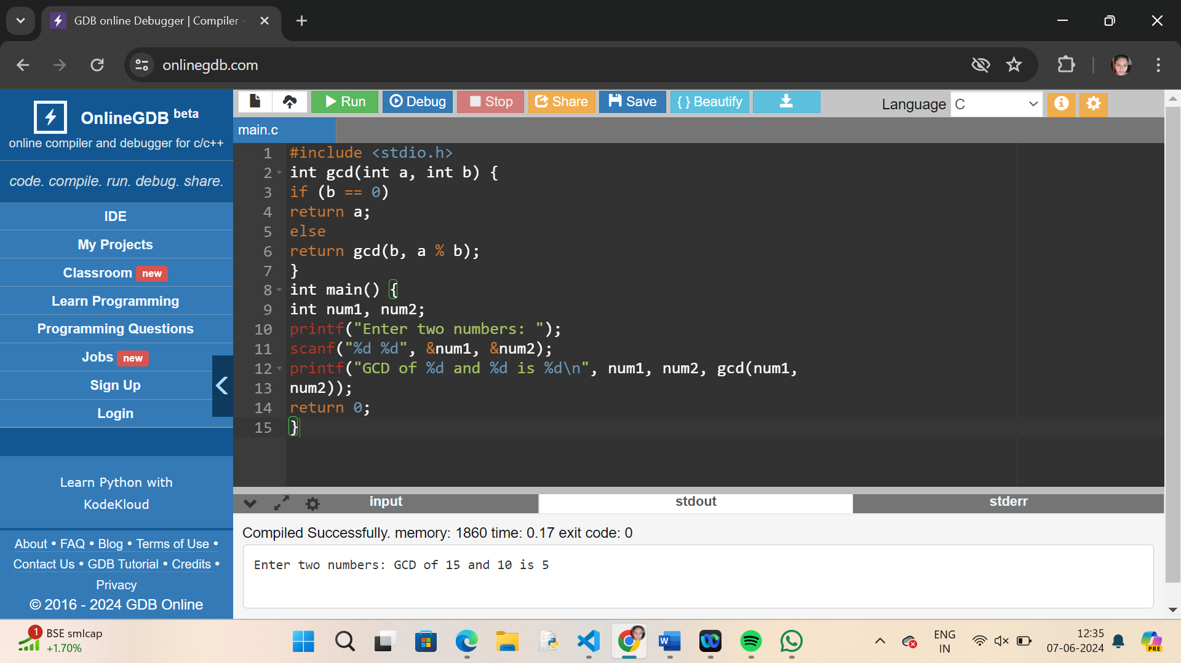

1. LARGEST NUMBER IN AN ARRAY

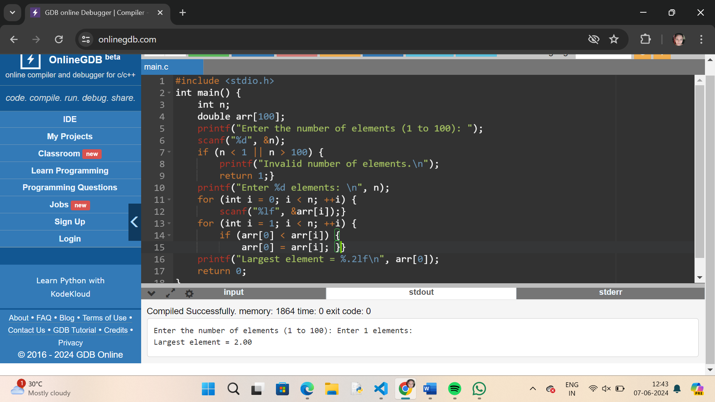

1. FACTORIAL OF A NUMBER USING RECTURSION

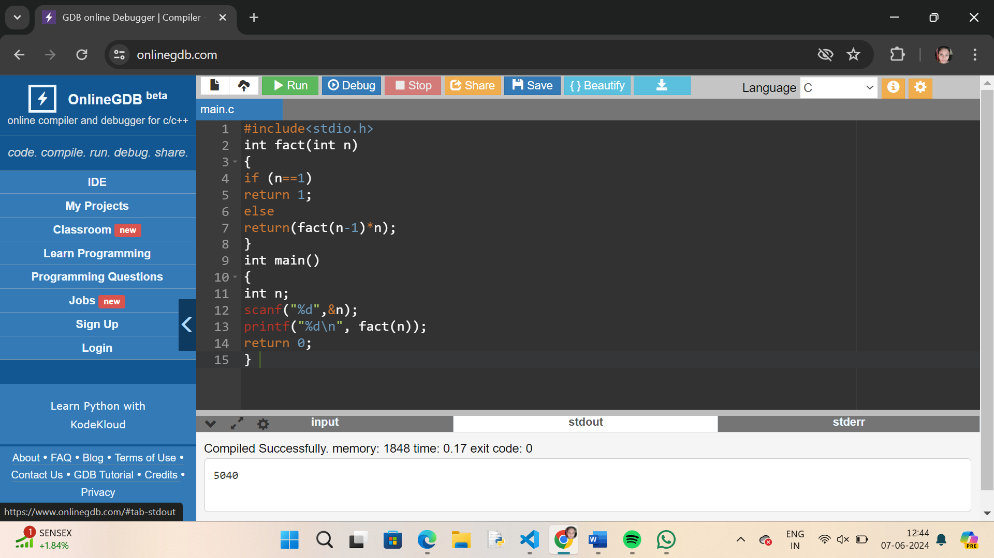

1. COPY STRING TO ANOTHER USING RECURSION

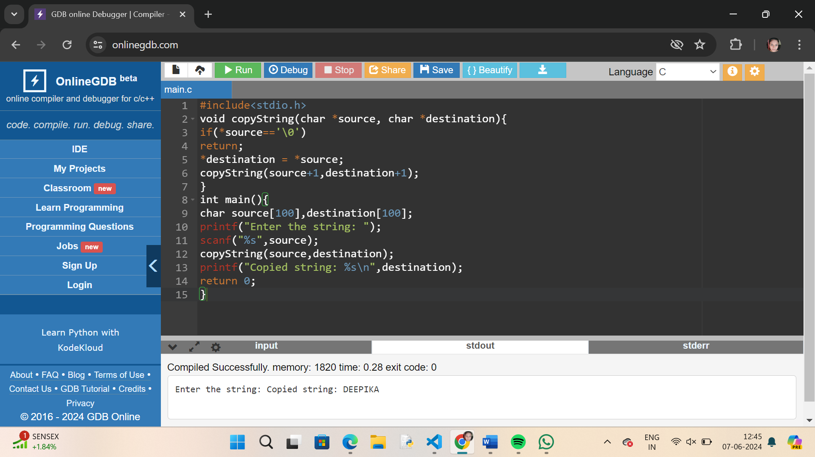

1. REVERSE A STRING USING RECURSION

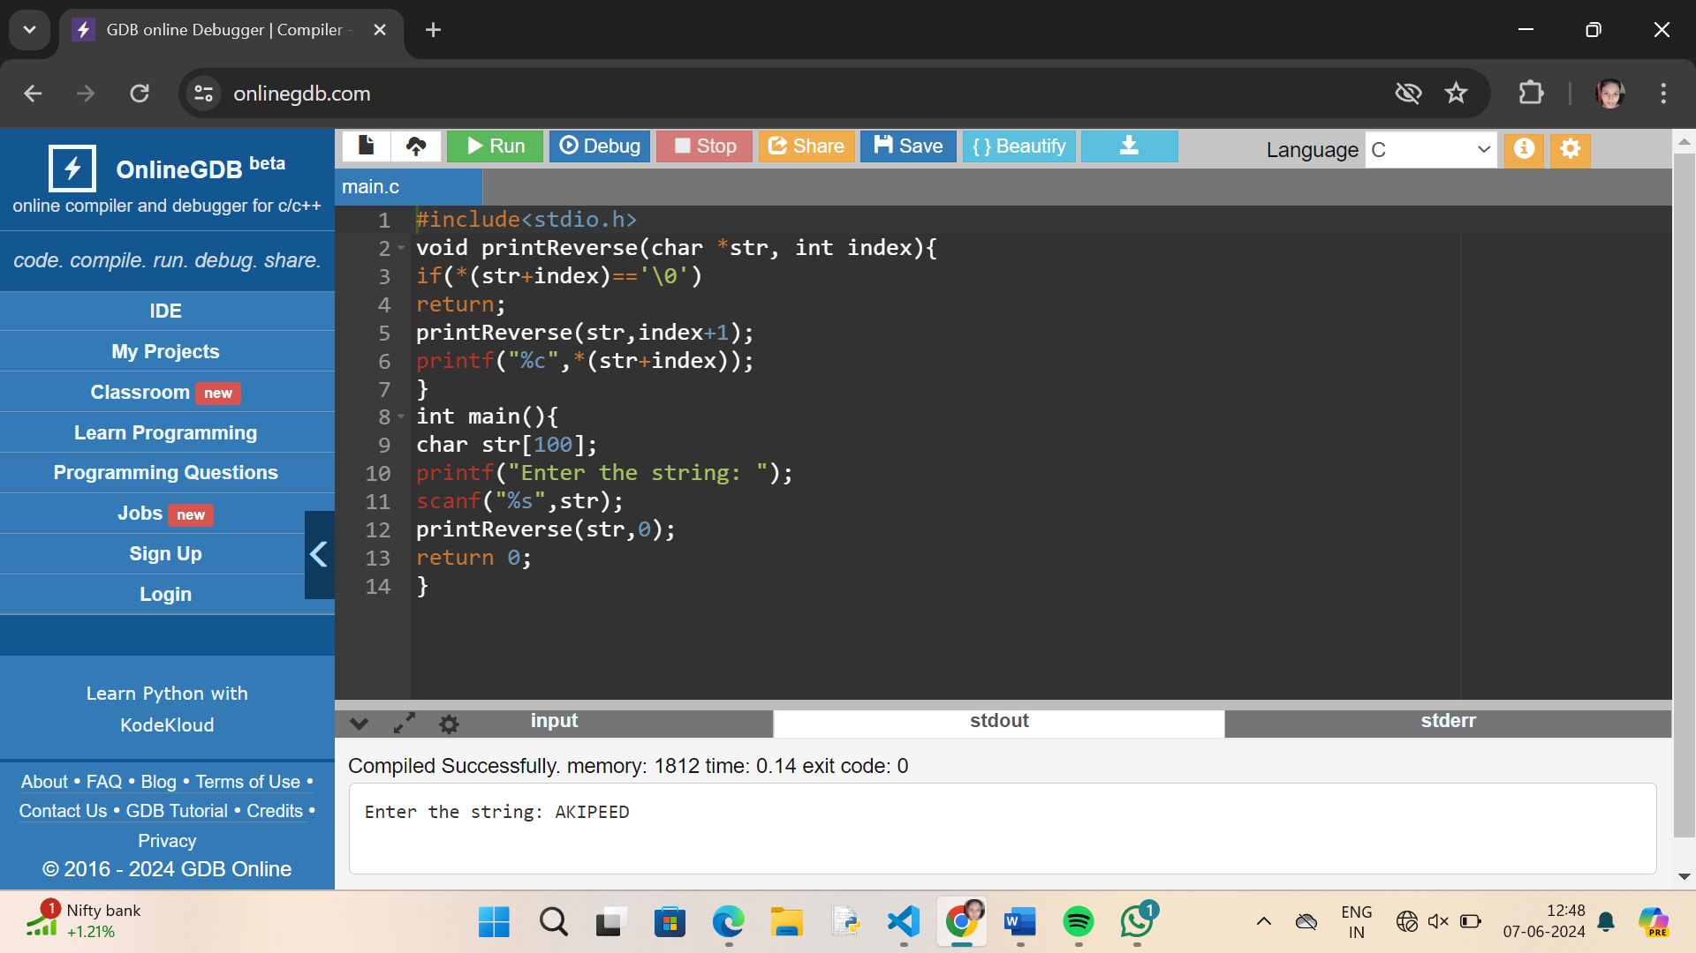

1. PRIME NUMBER OR NOT

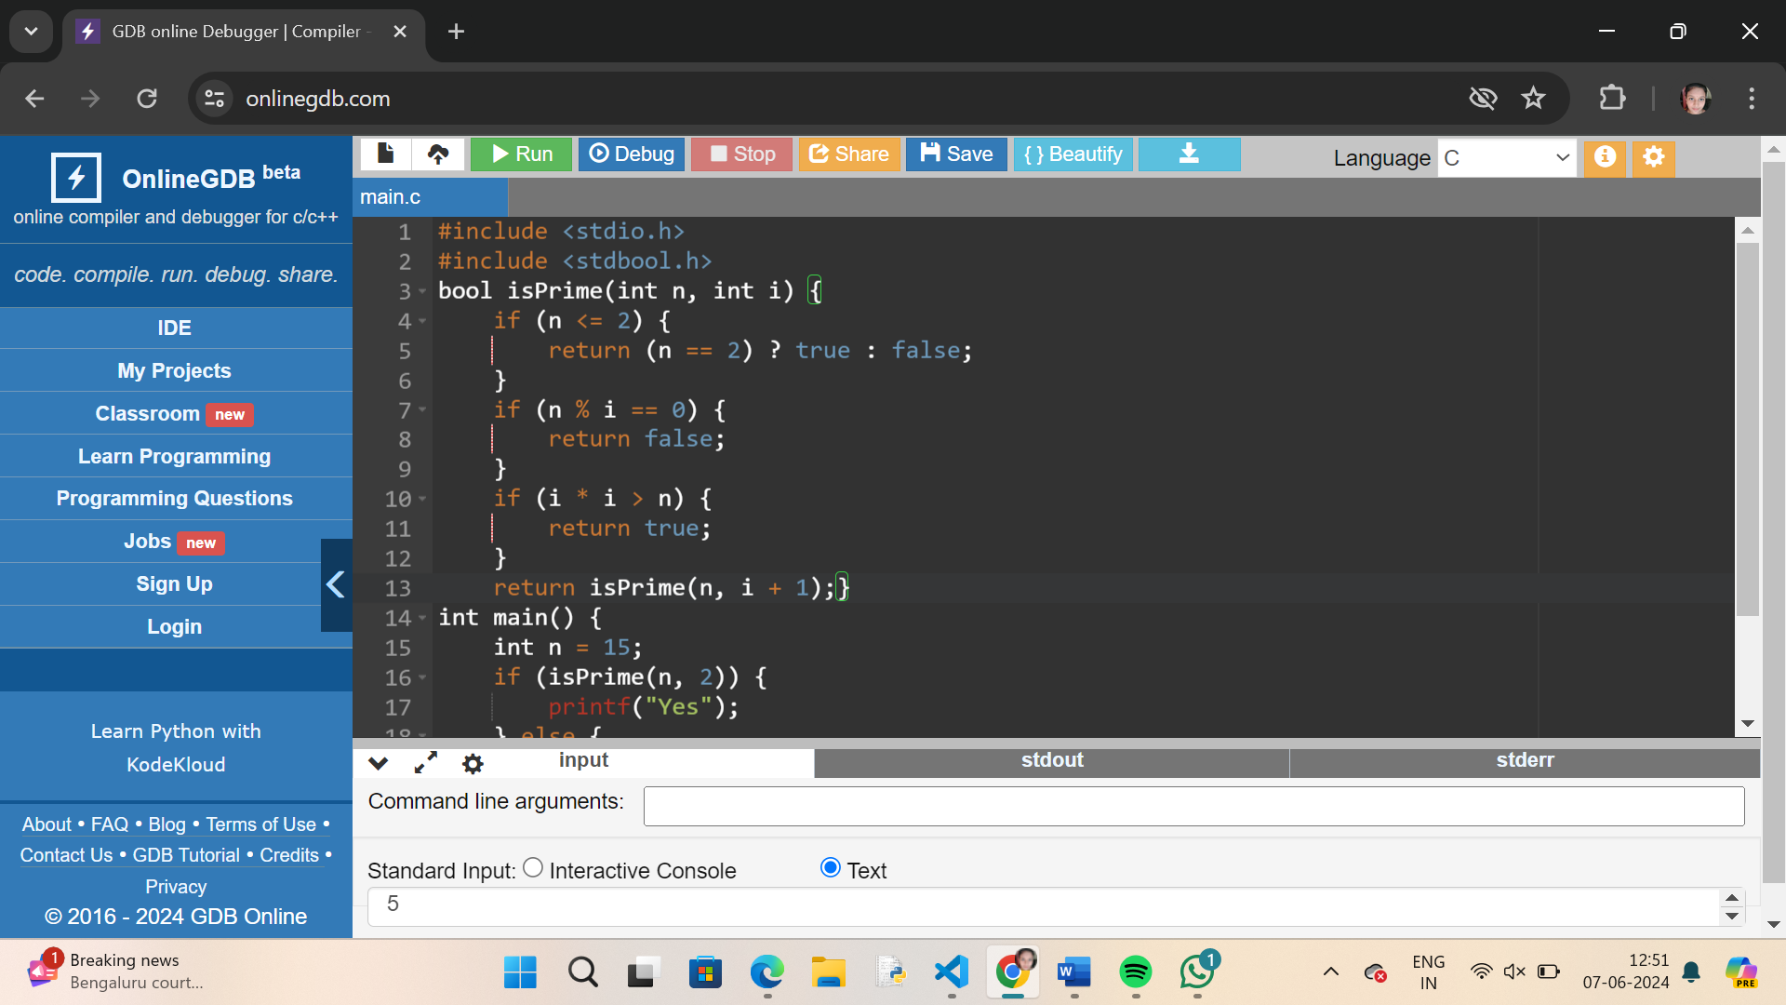

1. PRIME NUMBERS FROM 1-100

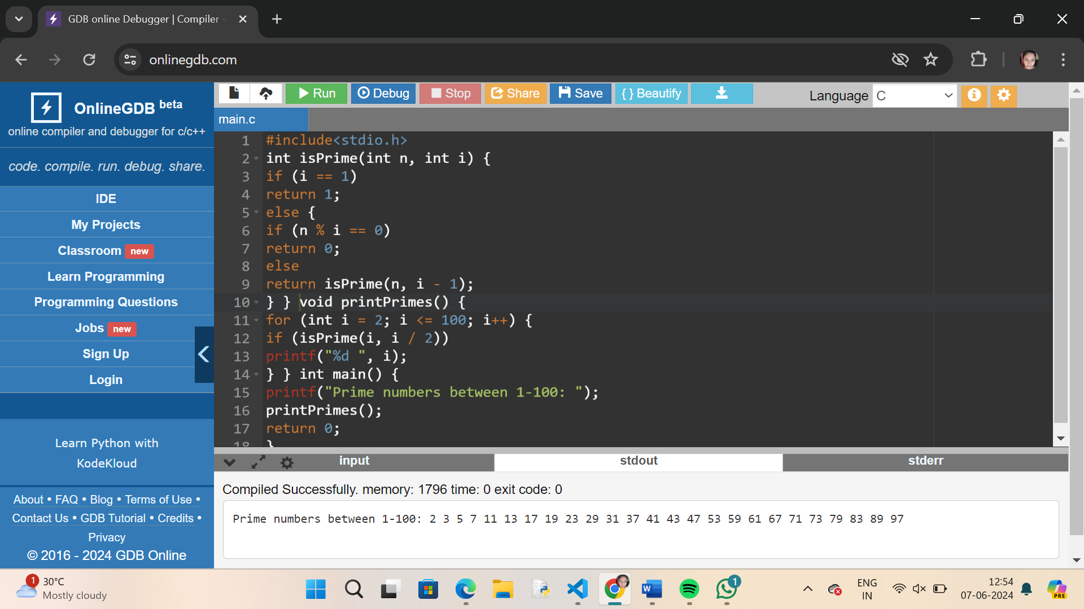

1. STRING IS PALINDROME OR NOT

